PROJECT NAME : SOCIAL MEDIA

Objective Questions

1. Are there any tables with duplicate or missing null values? If so, how would you handle them?
Answer - After performing comprehensive data validation across all tables in the ig_clone database, no duplicate records or no NULL values were found in any of the critical columns.
- Duplicate checks were conducted using GROUP BY and HAVING COUNT(*) on both primary keys and other columns.
- Additionally, NULL checks were performed.
FOR EXAMPLE :
QUERY 1
Select count(*) from comments
where id is null
or comment_text is null
or user_id is null
or photo_id is null
or created_at is null;
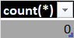

QUERY 2
select
id,
count(*)
from users
group by id
having count(*) > 1;
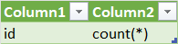

If duplicates were present, they would be handled by :
- Removing records using ROW_NUMBER() or DELETE queries.
- Enforcing PRIMARY KEY and UNIQUE constraints to prevent future duplicates.
If NULL values were found, they would be handled by :
- Removing incomplete records if they affect data integrity.
- Applying NOT NULL constraints to critical columns.

2. What is the distribution of user activity levels (e.g., number of posts, likes, comments) across the user base?
Answer - The distribution of user activity levels was analyzed by calculating the number of posts, likes and comments performed by each user across the platform.
QUERY
Select
u.id,
count(distinct p.id) as TotalPosts,
count(distinct l.photo_id) as TotalLikes,
count(distinct c.id) as TotalComments
from users u
left join photos p
on u.id = p.user_id
left join likes l
on u.id = l.user_id
left join comments c
on u.id = c.user_id
group by u.id;
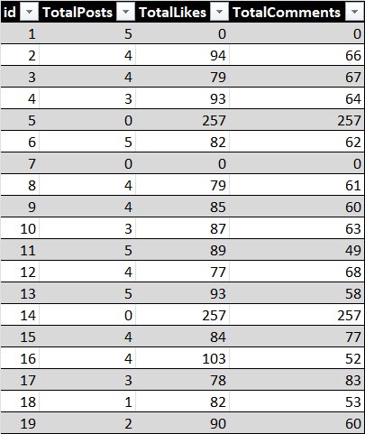

QUERY :
select
activity_level,
count(*) as total_users
from (
select
u.id,
case when count(p.id) = 0 then 'Inactive'
when count(p.id) between 1 and 3 then 'Low Activity'
when count(p.id) between 4 and 7 then 'Medium Activity'
else 'High activity'
end as activity_level
from users u
left join photos p
on u.id = p.user_id
group by u.id) as user_activity
group by activity_level;

3.Calculate the average number of tags per post (photo_tags and photos tables).
Answer : The average number of tags per post was calculated using the Photos and PhotoTags tables.
-It was observed that the average number of tags per post is 0 as no records were found in the PhotoTags table. This indicates that no tags have been assigned to any posts in the dataset.
QUERY
select
avg(tag_count) as AvgTagsPerPost
from (
select
p.id as photoID,
count(pt.tag_id) as tag_count
from photos p
left join photo_tags pt
on p.id = pt.photo_id
group by p.id
)t;
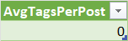

4.Identify the top users with the highest engagement rates (likes, comments) on their posts and rank them.
Answer : The top users were identified based on the total engagement received on their posts, calculated as the sum of likes and comments.
-Users were ranked using a window function based on their engagement levels.
QUERY
select
p.user_id,
count(distinct l.user_id) + count(distinct c.id) as TotalEngagement,
rank() over(order by count(distinct l.user_id) + count(distinct c.id) desc) as RankPosition
from photos p
left join likes l
on p.id = l.photo_id
left join comments c
on p.id = c.photo_id
group by p.user_id
order by RankPosition;
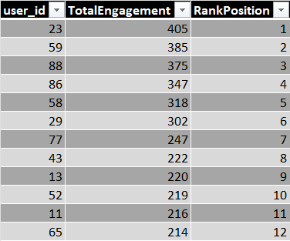

-The analysis reveals that User 23 has the highest engagement (405 interactions), followed by User 59 and User 88. These users significantly outperform others in terms of engagement.

5. Which users have the highest number of followers and followings?
Answer : The users with the highest number of followers and followings were identified separately using the follows table.
QUERY 1
select
followee_id as userID,
count(*) as TotalFollowers
from follows
group by followee_id
order by TotalFollowers desc;

QUERY 2
select
follower_id as userID,
count(*) as TotalFollowing
from follows
group by follower_id
order by TotalFollowing desc;
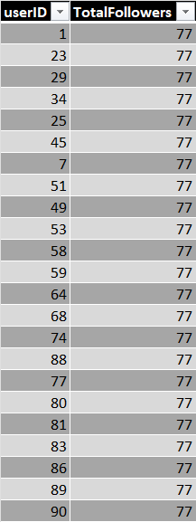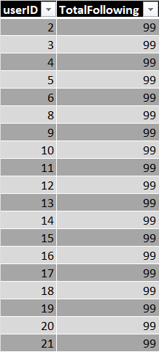
-It was observed that multiple users (such as User 1, 23, 29, 34, etc.) have the highest number of followers with a maximum count of 77 followers.
-Similarly, users such as User 2, 3, 4, 5, and others have the highest number of followings, with a maximum count of 99 followings.

6.Calculate the average engagement rate (likes, comments) per post for each user.
Answer: The average engagement rate per post was calculated for each user by dividing total engagement (likes + comments) by the total number of posts.
QUERY
select
p.user_id,
count(distinct p.id) as total_posts,
count(distinct l.user_id) + count(distinct c.id) as total_engagement,
(count(distinct l.user_id) + count(distinct c.id)) / count(distinct p.id) as avg_engagemnt_per_post
from photos p
left join likes l
on p.id = l.photo_id
left join comments c
on p.id = c.photo_id
group by p.user_id;

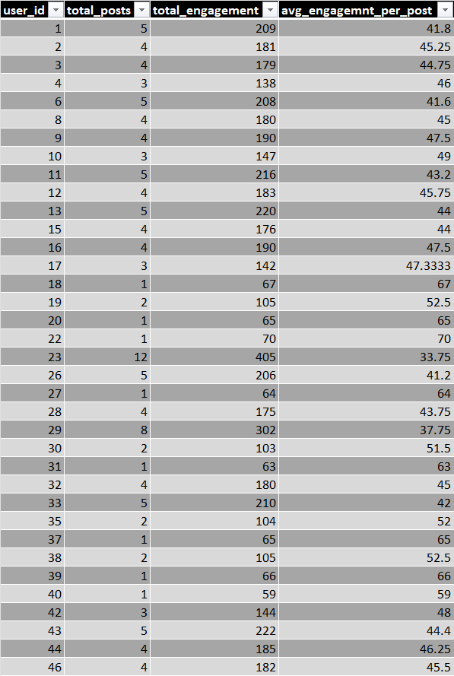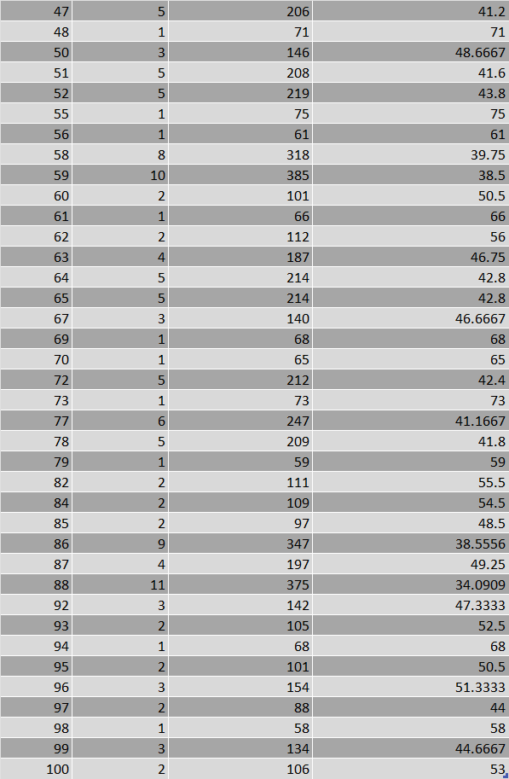
From the analysis:
-User 55 has the highest average engagement per post (~75) indicating strong audience interaction despite having only one post.
-Users like 9, 16 and 17 also show high engagement rates (above 45) suggesting consistent content performance.
-Users like 23 and 88 have relatively lower engagement per post (~33–34) indicating comparatively lower interaction.

7.Get the list of users who have never liked any post (users and likes tables).
Answer : -To identify users who have never liked any post, a LEFT JOIN was performed between the Users and Likes tables.
-Users with no matching records in the Likes table were filtered using a NULL condition.
QUERY :
select
u.id,
u.username
from users u
left join likes l
on u.id = l.user_id
where l.user_id is null;

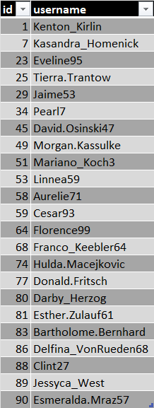
-The results show the list of inactive users in terms of likes indicating users who have not interacted with any posts.

8.How can you leverage user-generated content (posts, hashtags, photo tags) to create more personalized and engaging ad campaigns?
Approach : User activity can be analyzed through SQL using posts, likes, comments and hashtags.
Using Posts for interest-based ads :
QUERY :
select
u.id,
count(p.id) as total_posts
from users u
join photos p
on u.id = p.user_id
group by u.id
order by total_posts desc;
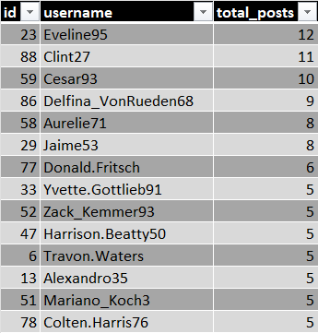

Insights :
-Users like Eveline95, Clint27, Cesar93 are the most active.
- A small group of users contributes a major portion of content.

Using Hashtags to identify trends :
QUERY :
select
t.tag_name,
count(pt.photo_id) as usage_count
from tags t
left join photo_tags pt
on t.id = pt.tag_id
group by t.tag_name;
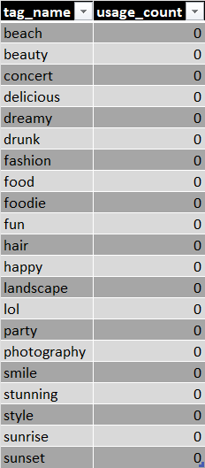
Insights :
-All hashtags have usage_count = 0
-No hashtag-post relationship exists in dataset.
-Missing data limits campaign personalization.
Using likes and comments for behavior analysis :
QUERY :
select
p.user_id,
count(distinct l.user_id) as total_likes,
count(distinct c.user_id) as total_comments
from photos p
left join likes l
on p.id = l.photo_id
left join comments c
on p.id = c.photo_id
group by p.user_id
order by total_likes desc,total_comments desc;

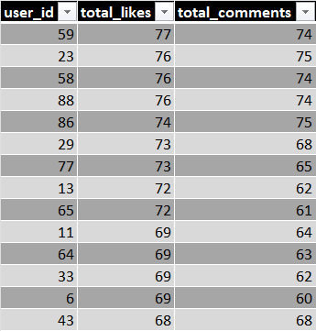
Insights :
-Users like user_id 59, 23, 58 have very high likes and comments.
-These users create highly engaging content.

Using photo tags for social targeting :
QUERY :
select
photo_id,
count(tag_id) as total_tags
from photo_tags
group by photo_id;
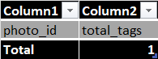
Insights :
-Output shows no meaningful tagging data.
- Cannot identify friend groups and social connections.
-This limits community-based targeting.

Recommendations :
-Target top creators with sponsored collaborations and creator focused ads.
- Use their content behavior to predict trending topics.
-Promote high engagement content in ads.
-Design ads similar to content that gets high likes and comments.

9.Are there any correlations between user activity levels and specific content types (e.g., photos, videos, reels)? How can this information guide content creation and curation strategies?

Answer : To analyze the relationship between user activity and engagement, a statistical correlation was calculated between the number of posts and the total engagement (likes and comments) per user.
QUERY
with user_stats as (
select
p.user_id,
count(distinct p.id) as posts,
count(distinct l.user_id) + count(distinct c.id) as engagement
from photos p
left join likes l
on p.id = l.photo_id
left join comments c
on p.id = c.photo_id
group by p.user_id
)
select
(avg(posts * engagement) - avg(posts) * avg(engagement)) /
(stddev(posts) * stddev(engagement)) as correlation
from user_stats;
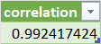

Insights :
-The correlation value obtained is 0.9924.
-This value indicates a very strong positive correlation between the number of posts and user engagement. It means that users who post more tend to receive significantly higher likes and comments.
-The strong positive correlation between posting frequency and engagement provides valuable insights for content strategy.
- Encourage Consistent Posting
- Focus on Content Volume
- Identify High-performing Content
- Support active creators
- Improve content Personalization

10.Calculate the total number of likes, comments, and photo tags for each user.
Answer : The total number of likes, comments and photo tags for each user was calculated to analyze user engagement and content interaction levels.
QUERY
select
p.user_id,
count(distinct l.user_id, l.photo_id) as total_likes,
count(distinct c.id) as total_comments,
count(distinct pt.tag_id, pt.photo_id) as total_tags
from photos p
left join likes l
on p.id = l.photo_id
left join comments c
on p.id = c.photo_id
left join photo_tags pt
on p.id = pt.photo_id
group by p.user_id;
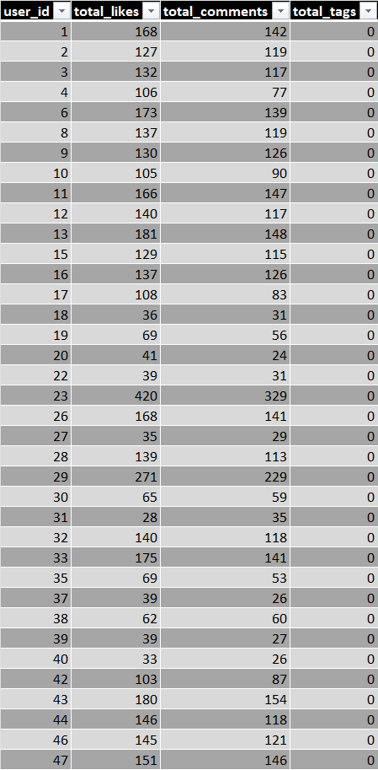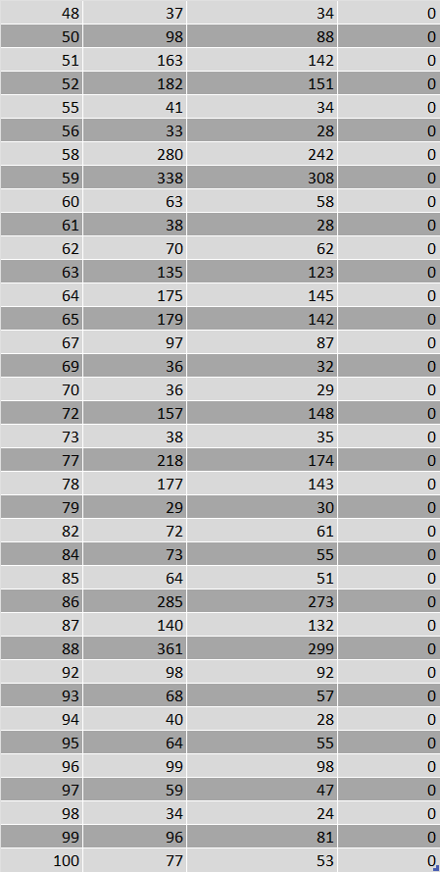
-It was observed that all users have 0 tags indicating that the tagging feature is not used or not populated in the dataset.
-User 23 has the highest likes (420) and strong comments (329) indicating high engagement.

11.Rank users based on their total engagement (likes, comments, shares) over a month.
Answer : To identify the most active and influential users, engagement was calculated by combining likes and comments received on posts within the last one month. Users were then ranked based on their total engagement.
QUERY
select
p.user_id,
count(distinct l.user_id,l.photo_id) +
count(distinct c.id) as total_engagement,
rank() over(order by count(distinct l.user_id,l.photo_id) +
count(distinct c.id) desc) as rank_position
from photos p
left join likes l
on p.id = l.photo_id
and l.created_at >= curdate() - interval 1 month
left join comments c
on p.id = c.photo_id
and c.created_at >= curdate() - interval 1 month
where p.created_dat >= curdate() - interval 1 month
group by p.user_id;
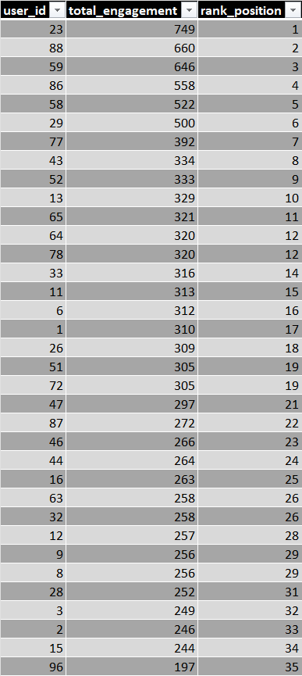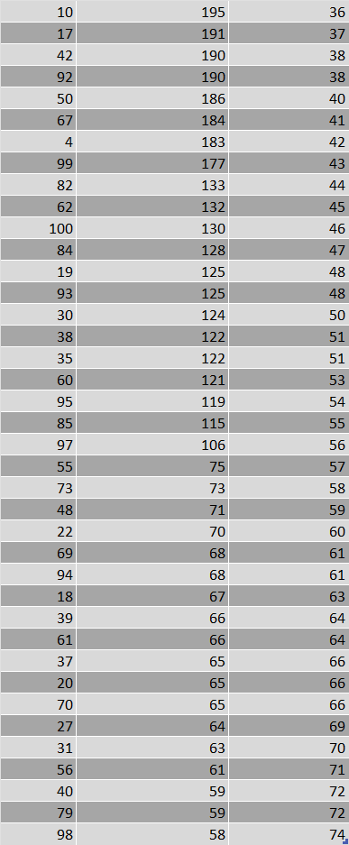
-User 23 has the highest engagement (749) → Rank 1
-User 88 follows with 660 → Rank 2
-User 59 has 646 → Rank 3
-Other top performers include users 86, 58, and 29.

12.Retrieve the hashtags that have been used in posts with the highest average number of likes. Use a CTE to calculate the average likes for each hashtag first.
Answer : To identify the hashtags associated with posts receiving the highest average number of likes, a Common Table Expression (CTE) was used. This approach helps in calculating aggregated metrics in a structured and readable manner.
QUERY
with hashtag_likes as (
select
t.tag_name,
count(l.photo_id) as total_likes,
count(distinct p.id) as total_posts,
count(l.photo_id) / count(distinct p.id) as avg_likes
from photo_tags pt
join tags t
on pt.tag_id = t.id
join photos p
on pt.photo_id = p.id
left join likes l
on p.id = l.photo_id
group by t.tag_name
)
select * from hashtag_likes
order by avg_likes desc;
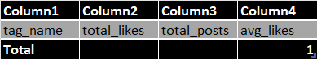

OBSERVATION
-The query returned no results.
-The photo_tags table in the dataset is empty
-This means:
-No hashtags are linked to any photos
-No relationship exists between posts and hashtags
-Therefore, no calculations for average likes per hashtag can be performed
CONCLUSION
-Since the dataset does not contain any records in the photo_tags table, it is not possible to identify hashtags or compute their average engagement.

13.Retrieve the users who have started following someone after being followed by that person.
Answer : To identify the users who started following someone after being followed by that person , a JOIN function was used.
QUERY
select
f2.follower_id as user_id,
f2.followee_id as followed_back_user
from follows f1
join follows f2
on f1.follower_id = f2.followee_id
and f1.followee_id = f2.follower_id
where f2.created_at >= f1.created_at;
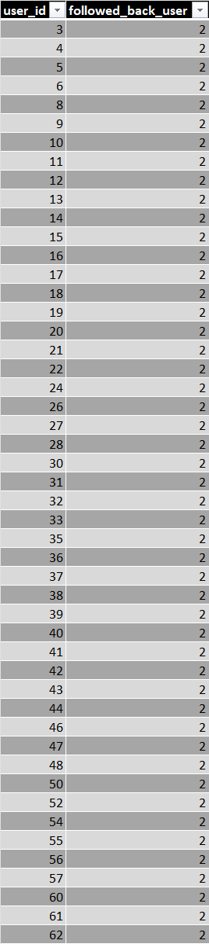

Subjective Questions

1.Based on user engagement and activity levels, which users would you consider the most loyal or valuable? How would you reward or incentivize these users?

Approach : To identify the most valuable users, we analyze user engagement across key activities: -Number of posts created
-Number of likes given
-Number of comments made
Since different activities contribute differently to platform growth, we assign relative importance:
Posts → highest value (content creation)
Comments → medium value (interaction)
Likes → lowest value (passive engagement)
Query :
select
u.id,
u.username,
count(distinct p.id) as total_posts,
count(distinct l.user_id) as total_likes,
count(distinct c.id) as total_comments,
(count(distinct p.id) * 5 + count(distinct c.user_id) * 3 + count(distinct l.user_id) * 1) as engagement_score
from users u
left join photos p
on u.id = p.user_id
left join likes l
on u.id = l.user_id
left join comments c
on u.id = c.user_id
group by u.id, u.username
order by engagement_score desc
limit 10;
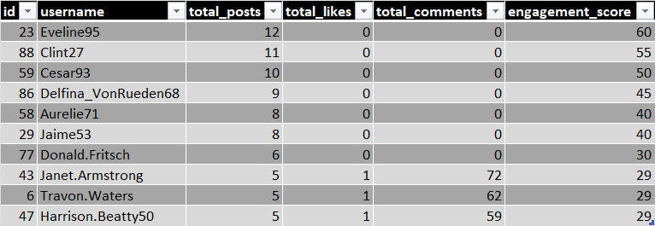
Insights :
-Top users like Eveline95, Clint27 have high number of posts but likes and comments are zero.
- Still ranked highest due to post weight.
- Content creation is biggest driver of engagement score.
- Highly interactive users like Janet.Armstrong rank lower as content creation is less.
- Many top users have only posts – no likes or comments.
Recommendations :
-Reward top content creators by giving “top creator” badge or progile visibility boost.
- Convert active commentors into creators.
- Encourage passive users to interact.
- Introduce user segmentation by creating categories of gold users (top creators), silver users (moderate activity), bronze users (low engagement).

2.For inactive users, what strategies would you recommend to re-engage them and encourage them to start posting or engaging again?
Approach : To identify inactive users, we analyze user activity based on their posting behavior. A user is considered inactive if they have never posted.
QUERY :
select
u.id,
u.username,
max(p.created_dat) as last_post_date
from users u
left join photos p
on u.id = p.user_id
group by u.id, u.username
having last_post_date is null;
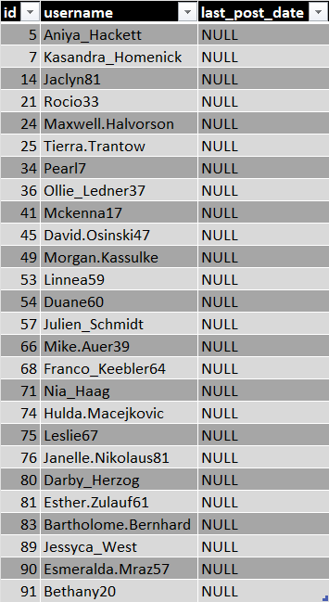

Insights :
-Many users have never posted even once.
-Inactive users represent a high potential segment for re-engagement campaigns.

To re-engage inactive users, we first need to understand why they became inactive:
Possible reasons for inactivity:
-Loss of interest or motivation
-Lack of relevant content or notifications
-Overwhelmed by platform changes or notifications
-Technical issues or difficulty in using the platform

Recommendations :
Re-engagement Strategies :
1.Personalized Communication : Personalized messages help users feel valued.
-Send emails like:
“We miss you!”
“Here’s what you missed”
“Top posts from your friends”
2. Gamification : People enjoy fun challenges and rewards.
-Leaderboards: Show users where they stand in terms of their activities compared to their friends or the community.
-Interactive Quizzes: Encourage users to engage through interactive content such as quizzes, polls and surveys.
3.Targeted Content for Re-engagement - Relevant content keeps users coming back.
-Tailored Recommendations: Show inactive users content that they were previously engaging with or similar content to what they liked in the past.
-Trending Content: Highlight popular or trending posts that might spark interest, such as posts from friends or similar groups.
-Friend Activity: Show them what their friends are engaging with and encourage interaction with friends' posts.
4.Simplify User Experience : Make it easy for users to re-engage without feeling overwhelmed.
-Simplify the Posting Process: Make posting content easier by offering a simplified user interface, easier upload tools or pre-set templates.
-Notify with Clear CTAs: Make sure notifications have a clear, easy-to-click CTA like "Post now" or "See what's new."
-Remind of Features: Gently remind users of platform features they may not be aware of or have forgotten about.
5.User Feedback and Surveys : Users feel valued when they know their opinion matters.
-Ask for Feedback: Send surveys to understand why they stopped using the platform and what can be improved.
-Act on Feedback: If feasible, make improvements based on the feedback and inform users that changes have been made.
6.Create Social and Emotional Connections : People feel more connected when they are part of a community.
-Encourage Friendships/Connections: Help users find friends or build connections on the platform. Sending friend suggestions or connection requests can bring them back.
-Celebrate Milestones: Remind users of their accomplishments on the platform — “You’ve been a part of this community for 1 year!” or “You have 100+ friends waiting to hear from you.”
-FOMO (Fear of Missing Out): Show inactive users what they are missing out on, like an exclusive event or a post they might like.

3.Which hashtags or content topics have the highest engagement rates? How can this information guide content strategy and ad campaigns?
Approach : To determine which content topics are most engaging, we’ll focus on total likes and total comments for each photo. We'll group them by user interactions to identify the most engaging content. Since tags are not available, we'll use photos as the unit of measurement.
QUERY :
select
p.id as photo_id,
p.image_url,
count(distinct l.user_id) as total_likes,
count(distinct c.user_id) as total_comments,
(count(distinct l.user_id) + count(distinct c.user_id)) / count(distinct p.id) as engagement_rate
from photos p
left join likes l
on p.id = l.photo_id
left join comments c
on p.id = c.photo_id
group by p.id
order by engagement_rate desc
limit 10;
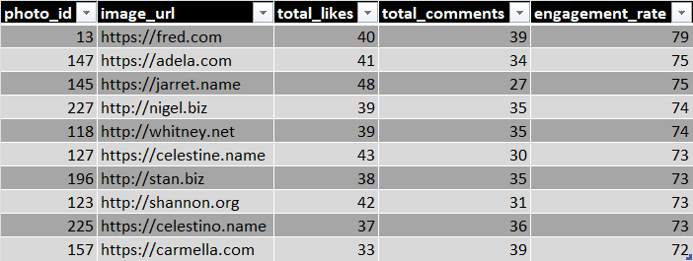

Insights :
-High Engagement content exists top photos have very high engagement (70+)
-This indicates strong user interest in certain content types.
-Balanced Interaction Pattern is there as Engagement is not just likes — comments are also high. Example: Photo 13 → 40 likes + 39 comments
-This means:
-Content is not just viewed
-It is actively discussed
-Some photos have almost equal likes and comments
This suggests:
-Content is emotionally engaging / discussion-worthy
-Consistency in Top Performers
-Engagement values are close (72–79)
This indicates that platform has multiple strong content pieces not just one viral post.
Recommendations :
1.Content Strategy :
-Identify patterns in top photos:
-Analyze these high-performing images manually
-Find common factors: Style (selfie, aesthetic, travel, etc.)
-Subject (people, food, lifestyle)
-Replicate successful content types:
-Create more content similar to top-performing photos.
2.Ad Campaign Strategy :
-Promote high-engagement content
-Use top photos in ads
-They are already validated by user interaction
-Target engaged users:
-Users who liked/commented are more likely to responsive to ads
-Use comment-driven ads:
-Ads that ask questions or opinions perform better
3.Platform Improvement :
Since tags are missing, the platform should implement a tagging/hashtag system to better categorize content and enable deeper engagement analysis.

4.Are there any patterns or trends in user engagement based on demographics (age, location, gender) or posting times? How can these insights inform targeted marketing campaigns?
Approach : The dataset does not contain demographic fields such as age, gender or location. Therefore, demographic based analysis is not possible.
-We focus on time-based engagement analysis using created_dat from photos
-Engagement metrics are likes and comments.
-This helps us identify when users are most active on the platform.
QUERY :
select
hour(p.created_dat) as post_hour,
count(distinct l.user_id) as total_likes,
count(distinct c.user_id) as total_comments,
(count(distinct l.user_id) + count(distinct c.user_id)) as engagement
from photos p
left join likes l
on p.id = l.photo_id
left join comments c
on p.id = c.photo_id
group by hour(p.created_dat)
order by engagement desc;
Insights :
-All engagement is concentrated at 21st hour (9 PM)
-Strong user activity at night indicates users are highly active during night hours.
-Only one time value exists
This suggests:
-Either data is limited or all posts were made at the same time.
Recommendations :
1. Posting Strategy :
-Schedule posts around 9 PM
-This is the highest engagement window
2. Marketing Campaign Timing :
-Run ads during evening hours (8 PM – 10 PM)
-This ensures maximum visibility and higher interaction rates
3. Engagement Optimization :
-Since comments are high:
-Use interactive content
-Questions
-Polls
-Discussions
4. Platform Improvement :
-To enable deeper analysis, the platform should collect demographic data such as age, gender and location and ensure more diverse timestamp data for better trend identification.

5.Based on follower counts and engagement rates, which users would be ideal candidates for influencer marketing campaigns? How would you approach and collaborate with these influencers?
Approach : The objective is to identify ideal influencers using two key metrics:
Key Factors Considered :
-Follower Count (Reach)
-From follows table
-Indicates how many people the user can influence
-Engagement Score (Impact)
-Based on likes and comments
-Indicates how actively the audience interacts
QUERY :
select
u.id as user_id,
u.username,
count(distinct f.follower_id) as total_followers,
count(distinct l.photo_id) as total_likes,
count(distinct c.photo_id) as total_comments,
(count(distinct l.photo_id) + count(distinct c.photo_id)) as engagement_score
from users u
left join follows f
on u.id = f.followee_id
left join photos p
on u.id = p.user_id
left join likes l
on p.id = l.photo_id
left join comments c
on p.id = c.photo_id
group by u.id
order by total_followers desc,engagement_score desc
limit 10;
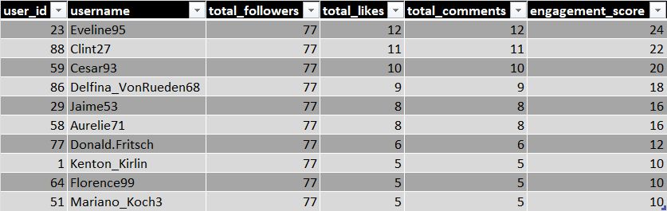
Insights :
1. Equal Follower Count :
-All top users have same followers (77)
-This means dataset has uniform follower distribution.
2. Engagement Becomes Key Factor :
-Since followers are same users with higher engagement score are better influencers
-Example: Eveline95 (24) > Clint27 (22) > Cesar93 (20)
3. Active Audience Indicator :
-Engagement is balanced: Likes ≈ Comments
-This shows audience are actively interacting not just scrolling.
4. Micro-Influencer Pattern :
-Followers are relatively low (77) but engagement is consistent
-These users behave like micro-influencers with strong niche engagement
Recommendations :
1. Influencer Selection Strategy :
-Prioritize users with highest engagement score.
-Since followers are equal, engagement is deciding factor.
Best candidates:
- Eveline95
- Clint27
- Cesar93
2. Collaboration Approach :
-Reach out with personalized message and acknowledge their engagement
3. Collaboration Models :
-Offer Sponsored posts and Affiliate partnerships
4. Campaign Strategy :
-Use influencers for Product promotions, Social media challenges, Brand awareness
5. Performance Tracking :
-Monitor likes & comments on sponsored posts
-Select influencers for long-term partnerships based on performance.

6.Based on user behavior and engagement data, how would you segment the user base for targeted marketing campaigns or personalized recommendations?
Approach :Users are classified into segments based on:
-Content Creators - High number of posts
-Highly Engaged Users - High likes + comments
-Moderately Active Users - Some activity but not high
-Inactive Users - No posts, likes or comments
This segmentation helps in understanding different user roles on the platform.
QUERY :
Select
u.id,
u.username,
count(distinct p.id) as total_posts,
count(distinct l.photo_id) as total_likes,
count(distinct c.photo_id) as total_comments,
case
when count(distinct p.id) >= 10 then 'content creator'
when count(distinct l.photo_id) + count(distinct c.photo_id) >= 15 then 'highly engaged user'
when count(distinct p.id) = 0 and count(distinct l.photo_id) = 0
and count(distinct c.photo_id) = 0 then 'inactive user'
else 'moderately active user'
end as user_segment
from users u
left join photos p on u.id = p.user_id
left join likes l on u.id = l.user_id
left join comments c on u.id = c.user_id
group by u.id, u.username;
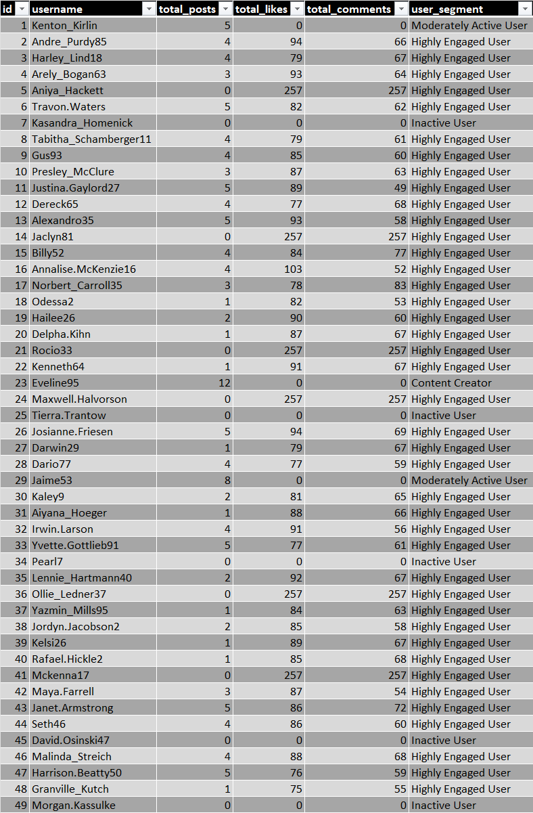
Insights :
1. Highly Engaged Users Dominate :
-Many users have very high likes and comments (e.g., 257 each) but zero posts.
-This means they are consumers, not creators .
They actively interact with content
2. Content Creators Are Few :
-Example: Cesar93 → 10 posts but no engagement
This indicates:
-Some users create content but don’t engage with others.
3. Clear Behavioral Differences :
-Users fall into distinct categories:
-Creators
-Engagers
-Passive users
-This confirms platform has diverse user roles.
4. Inactive Users Exist :
-Some users have 0 posts, 0 likes, 0 comments
-These users are at risk of churn (leaving platform)
5. Imbalance in Platform Behavior :
-Many users engage but don’t post
-Few users post but don’t engage
-This indicates need to balance content creation vs interaction.
Recommendations :
1. For Highly Engaged Users
-Encourage them to start posting
-Use “Share your first post” prompts and content suggestions
2. For Content Creators
-Encourage engagement by suggesting commenting/liking others’ posts.
3. For Moderately Active Users
-Push them toward higher activity by sending notifications and showing trending content.
4. For Inactive Users
-Run re-engagement campaigns like Emails, App notifications.

7.If data on ad campaigns (impressions, clicks, conversions) is available, how would you measure their effectiveness and optimize future campaigns?
Approach : In the current dataset, there is no direct data available for impressions, clicks and conversions. Therefore, direct measurement of ad campaign effectiveness is not possible using the existing dataset.
-If Ad Data Were Available, we would measure campaign effectiveness using key metrics:
-CTR (Click Through Rate) → Clicks / Impressions
-Conversion Rate → Conversions / Clicks
-Overall Performance → Conversions / Impressions
-Since actual ad data is missing, we rely on engagement-based performance:
-Impressions : Followers
- Clicks : Likes
- Conversion : Comments
Insights :
-Engagement as a Proxy for Effectiveness :
- High likes → Users are interested in content
- High comments → Users are actively involved
-This mimics:
- Click behavior
- Conversion intent
- If:
- Likes high, comments low → weak conversion
- Both high → strong campaign
- Highly Engaged Users = Best Target Audience
- Users with high likes/comments:
-More likely to respond to ads
-Higher conversion probability
Recommendations :
1. Target High Engagement Users :
-Run campaigns for highly engaged users
-They act like high conversion audience
2. Retarget Active users who frequently like/comment
-Show them personalized ads

8.How can you use user activity data to identify potential brand ambassadors or advocates who could help promote Instagram's initiatives or events?
Answer : A good brand ambassador is someone who:
-Is highly active on the platform
-Has strong engagement behavior
-Consistently interacts with content
Approach : To identify potential brand ambassadors, users can be evaluated on the basis of their posting activity, engagement received and follower count.
QUERY :
select
u.id as user_id,
u.username,
count(distinct p.id) as total_posts,
count(distinct l.user_id) as total_likes,
count(distinct c.id) as total_comments,
count(distinct f.follower_id) as total_followers,
(count(distinct l.user_id) + count(distinct c.id) + count(distinct f.follower_id)
)as ambassador_score
from users u
left join photos p
on u.id = p.user_id
left join likes l
on p.id = l.photo_id
left join comments c
on p.id = c.photo_id
left join follows f
on u.id = f.followee_id
group by u.id, u.username
order by ambassador_score desc,total_posts desc
limit 10;
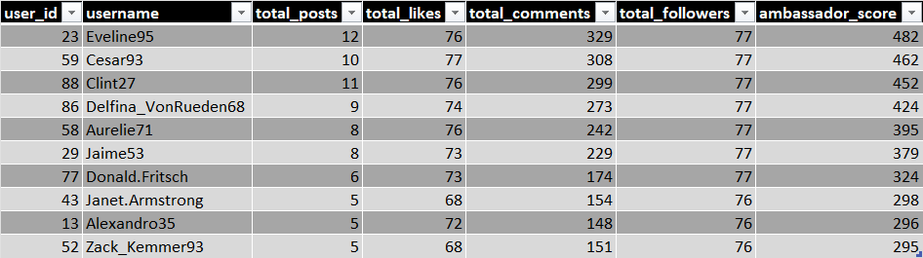
Insights :
- Users like Eveline95, cesar93, Clint27 have high ambassador score indicating strong overall influence.
- Users with both high followers and high engagement are the most valuable.
Recommendations :
- Collaborate with top-ranked users for promotions, launches and events.
- Don’t rely on few users, use multiple high scoring users for wider and more authentic reach.
- Target audiences engaging with these users using personalized ads and campaigns.
- Select users with high likes and comments as they drive better interaction and conversions.

9.How would you approach this problem, if the objective and subjective questions weren't given?
-If no predefined questions are provided, the approach would follow a data analytics workflow:
Step 1: Understand the Dataset (Data Exploration)
-Identify all tables: users, photos, likes, comments, follows , photo_tags
- Understand relationships between these tables.

Step 2: Define Business Objectives
Since no questions are given, I would define my own objectives such as:
- Identify most active users
- Analyze user engagement patterns
- Detect inactive users
- Identify potential influencers
- Understand content performance

Step 3: Perform Exploratory Data Analysis (EDA)
Run basic queries like:
- Total users
QUERY : Select count(*) as total_users from users;
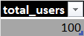

- Total posts
QUERY : Select count(*) as total_posts from photos;
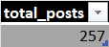

Step 4: Identify Key Metrics (KPIs)
Define important metrics such as:
- Engagement = Likes + Comments
QUERY :
select
p.user_id,
count(distinct p.id) as total_posts,
count(distinct l.user_id) + count(distinct c.id) as total_engagement
from photos p
left join likes l
on p.id = l.photo_id
left join comments c
on p.id = c.photo_id
group by p.user_id;
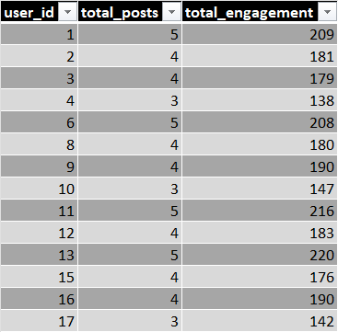
- Activity level = Number of posts
QUERY : select
User_id,
Count(*) as posts
from photos
group by user_id;
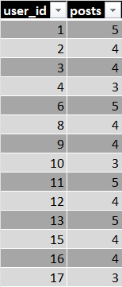

Step 5: Generate Insights
Based on analysis, identify:
- Who are the most active users
- Who are highly engaged users
- Which users are inactive
- What type of content performs well
Step 6: Perform Segmentation
Segment users into categories:
- Highly Engaged Users
- Content Creators
- Moderately Active Users
- Inactive Users
QUERY :
select
u.id,
u.username,
count(distinct p.id) as total_posts,
count(distinct l.photo_id) as total_likes,
count(distinct c.photo_id) as total_comments,
case
when count(distinct p.id) >= 10 then 'content creator'
when count(distinct l.photo_id) + count(distinct c.photo_id) >= 100 then 'highly engaged user'
when count(distinct p.id) = 0
and count(distinct l.photo_id) = 0
and count(distinct c.photo_id) = 0 then 'inactive user'
else 'moderately active user'
end as user_segment
from users u
left join photos p on u.id = p.user_id
left join likes l on u.id = l.user_id
left join comments c on u.id = c.user_id
group by u.id, u.username;
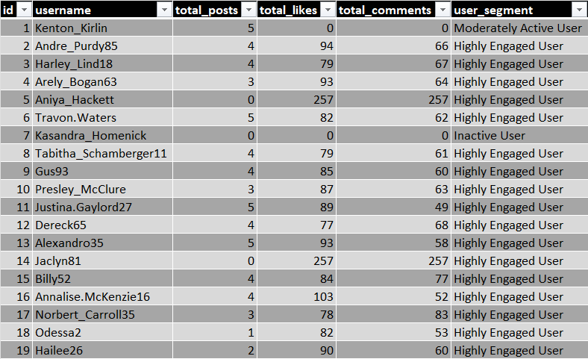
Step 7: Derive Business Recommendations
Convert insights into actions:
- Improve engagement
- Target high value users
- Re-engage inactive users
- Optimize content strategy

10.Assuming there's a "User_Interactions" table tracking user engagements, how can you update the "Engagement_Type" column to change all instances of "Like" to "Heart" to align with Instagram's terminology?
Approach : Use an UPDATE statement
-Apply a condition (WHERE clause) to only update rows where engagement_type = 'like'
-This ensures no unintended data is modified.
QUERY :
UPDATE user_interactions
SET engagement_type = 'heart'
WHERE engagement_type = 'like';
Conclusion :
The engagement type can be updated efficiently using an UPDATE statement with a WHERE clause to ensure only relevant records are modified. This helps maintain data consistency and aligns platform terminology with business requirements.

